Name: _____________________________________________________ Period: ______ VERSION A


2025-2026 Physics Final Exam

Gentlemen,

It has been a pleasure to teach all of you. Thank you for such a great year. Take your time while working on the exam and be sure to check your work. Good luck!

General Directions:
- Place your name, class period, Test Version and today’s date on all materials.
- Place all multiple-choice answers on the Scantron answer key.
- Show ALL work for free response questions in the space provided or on scrap paper.
- You may detach the formula sheet from this packet.

Student Honor Code
A student’s acceptance of enrollment in La Salle College High School and continuation of enrollment in La Salle are contingent upon the student’s acceptance of and adherence to the principles of this Student Honor Code.

RESPONSIBILITIES OF STUDENTS:
- To complete all academic work honestly and independently.
- To refrain from revealing any information regarding the contents of a test, directly or indirectly, to any other student who may subsequently take the same test.
- To refrain from unethical use of computers and/or cellphones.
- To refrain from personal dishonesty as more fully defined in this Honor Code.

Multiple Choice (Conceptual): Mark the letter of the best answer to the following questions on the Scantron sheet provided. (1 points each)

1. On the International Space Station, astronauts experience a feeling of weightlessness because:
a) gravity is not acting on them
b) they are in free fall around the earth
c) they are accelerating away from earth
d) their spacesuits are extremely lightweight

2. An astronaut weighing 700N on earth visits a faraway planet that has the same radius as earth, but twice the mass. What is their weight on the surface of this planet?
a) 350 N c) 1400 N
b) 700 N d) 2800 N

3. A material in which charges are not able to move freely is known as _______________.
a) a conductor c) an inductor
b) an insulator d) an interrupter

4. When Mr. Werman wants to safely approach the charged Van de Graaf generator, he touches the attached wand to the metal globe. While the wand is touching, he can approach the generator without risk of shock. This is an example of:
a) conduction c) transference
b) insulation d) grounding

5. An attracting force occurs between two charged objects when the…
a) charges are of unlike signs. c) charges are of like signs.
b) charges are of equal magnitude. d) charges are of unequal magnitude

6. A rod is given a negative charge by rubbing it with a cloth. Which of the following statements is true?
a) Protons have been removed from the rod. c) Electrons have been added to the rod.
b) The cloth has become negatively charged. d) The cloth has been left with a neutral charge.

7. In our analogy between Electricity and Plumbing, the “pressure” in the pipes represents:
a) the voltage c) the charge
b) the current d) the conductor

8. Which of the following configurations will light the bulb?
a) 1, 3, 4, and 5 c) 1, 3, and 4
b) 2, 3, and 5 d) All Five







1 2 3 4 5






9. Several resistors are wired in series. What is true about this circuit?
a) The sum of the currents through each resistor will equal the total circuit current
b) the total circuit current will be the same as the current through any one resistor
c) the voltage across any resistor is the same as the voltage of the power supply
d) the current in any single resistor is determined by its resistance and the voltage of the power supply

10. Alex and Brian both have class on the third floor. Alex climbs the two flights of stairs in half the time as Brian. If they both have the same mass, what can be said about the work done by Alex?
a) Alex did the same work as Brian c) Alex did half the work of Brian
b) Alex did twice the work as Brian d) Alex did not do any work

11. A roller coaster car travels through a vertical loop. Where do the riders experience the greatest G’s?
a) The top of the loop.
b) The bottom of the loop.
c) The sides of the loop.
d) All parts of the loop experience the same G’s.

12. For an object moving at constant speed and along a circular path, it must be experiencing a net force acting in which direction?
a) towards the center of the circular path
b) away from the center of the circular path
c) tangent to the circular path
d) none of the above…there is no net force on an object with constant speed.

13. When calculating an electrostatic force using Coulomb’s Law, a negative force indicates:
a) the force is to the left c) the objects are attracted
b) the force does not exist d) the objects are repelled



14. In figure shown, how many wavelengths are shown?
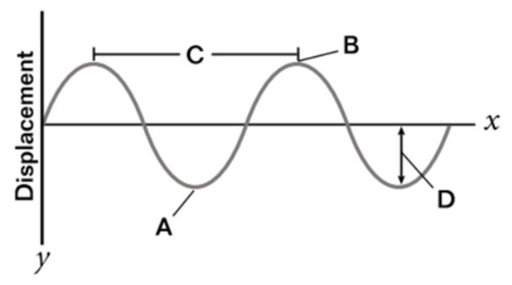
a) 1
b) 1.25
c) 2
d) 4

15. Four identical balls are released from rest at the top of four ramps. Each ramp has a different shape but starts and ends at the same height. What is true of the balls if released at the same time?
a) All four balls will reach the bottom of the ramps at the same time.
b) The kinetic energy of the balls will be the same at all times.
c) The gravitation potential energy of the balls will be the same at all times.
d) Each ball will have the same velocity as they exit the ramp.

Multiple Choice (Calculations): Mark the letter of the best answer to the following questions on the Scantron sheet provided. (2 points each)
16. Two students are sitting 2.0 m apart. One student has a mass of 50 kg and the other has a mass of 60 kg. What is the gravitational force of attraction between them?
a) 5.00 x 10⁻⁸ N c) 2.00 x 10⁻⁷ N
b) 1.00 x 10⁻⁷ N d) 3.20 x 10⁻⁸ N

17. What is the electric field strength 0.15 m from a source charge of +6 x 10⁻³ C?
a) 2.4 x 10⁹ N/C c) 1.44 x 10⁷ N/C
b) 3.6 x 10⁹ N/C d) 2.4 x 10⁸ N/C

18. What is the current through a 47 Ω resistor when connected to a 120 V source?
a) 0.39 A c) 2.55 A
b) 390 mA d) 21 mA

19. What is the kinetic energy of a 0.135 kg hockey puck shot at 40.0 m/s?
a) 54.0 J c) 216 J
b) 87.0 J d) 108 J

20. An ambulance siren wails at 2400 Hz. When speeding towards an observe at 20 m/s, what frequency will they hear? (Assume the speed of sound is 343 m/s)
a) 2268 Hz
b) 2400 Hz
c) 2549 Hz
d) 2260 Hz

21. A water strider insect on a calm pond beats its legs rhythmically, sending out continuous concentric ripples with a wavelength of 1.5 cm. The waves are observed to travel 1.2 m to a nearby lily pad in 4.0 s. What is the frequency of the ripples produced by the insect?
a) 5 Hz
b) 10 Hz
c) 20 Hz
d) 40 Hz

22. How much elastic potential energy is stored in a spring that has a stiffness of 300 N/m and is compressed 0.05 m?
a) 0.375 J
b) 15 J
c) 7.5 J
d) 0.75 J

23. A set of keys is twirled in a horizontal circle at the end of a 0.50 m long cord. If the keys are spinning with a constant speed of 3.0 m/s, what is their centripetal acceleration?
a) 4.5 m/s²
b) 6.0 m/s²
c) 9.0 m/s²
d) 18.0 m/s²

24. A 2.0 kg ball is dropped from a height of 5.0 m. Assuming there is no air resistance, how much kinetic energy will the ball have just before it hits the ground?
a) 10 J
b) 49 J
c) 98 J
d) 196 J

25. In the circuit shown, what is the resistance of the resistor marked with the star?
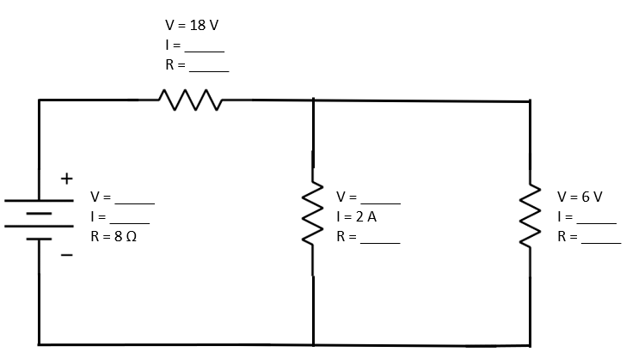
a) 1 Ω
b) 3 Ω
c) 6 Ω
d) 9 Ω

FREE RESPONSE PICK 4 of 5 NAME: _________________________ Pd:_______

To earn full credit, list all knowns/unknowns (with units), state the relevant equations you are using, show your steps clearly, and circle your final answer. (10 Points Each)

1. In the upcoming 12th test flight of the SpaceX Starship, the company is targeting an orbital insertion at an altitude of 230,000 m above the surface of earth.
FBD

a) Draw the FBD for the spacecraft while in orbit.

b) Calculate the orbital velocity of the spacecraft. _____________

2. An electric motor is plugged into a 120 V outlet and powers a conveyer belt. At full power (and operating at 100% efficiency), the belt can raise a 20 kg package 6 meters in 2.5 s.

a) Calculate the mechanical power output of the motor. ______________

b) How much current would the motor draw? ___________

3. During a physics demonstration, a rocket-powered toy cart with a mass of 3.0 kg is initially at rest. A buzzer attached to the cart emits a steady 480 Hz tone. The engine supplies 150 J to launch the car along the floor.
a) After launch, what frequency would a student in the room hear as the cart approaches? ____________
b) The cart then travels up an incline. How high would the cart travel before stopping? ____________

4. Two small charged balloons are resting on a frictionless lab table. Balloon A carries a charge of +3 μC and is held firmly in place. Balloon B has a mass of 0.06 kg and carries a charge of +2.0 μC. The balloons are separated by a distance of 0.15 m.
a) Calculate the electrostatic force acting on Balloon B when it is first released. _______________
b) Determine Balloon B’s initial acceleration immediately after release. ______________

5. A small child with mass of 30 kg sits on a merri-go-round 2 m from its center. The ride rotates with a frequency of 0.5 Hz.
FBD (side view)
a) Draw the FBD (side-view) for the child while rotating.

b) Determine the amount of friction acting on the child. ____________

